Anthem Software Simulator Installation Guide
A7, A12, A27 inch units only

Power cycle the unit and get into the Anthem Configuration, do you left, right, left repeatedly shown below when the see the prompt “One Moment Please”.

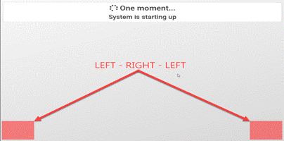

At the Maintenance Screen, Select Configuration

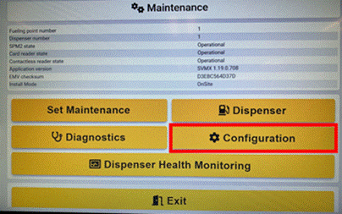

Enter 8311 for the access code.

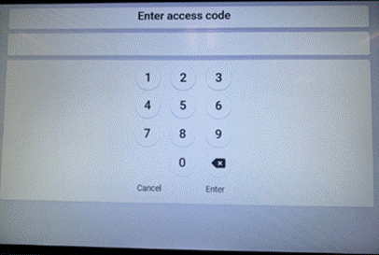

At the Configuration Menu, select SPM.

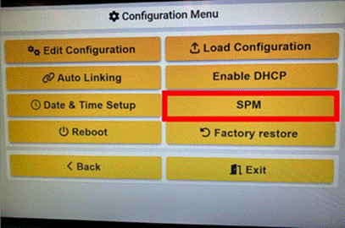

Select Svmx – Spm Pairing

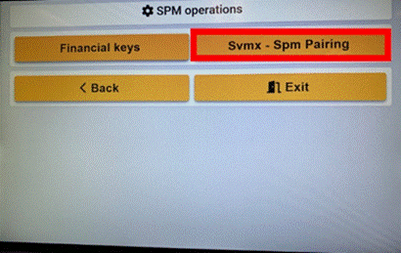

Select Unpair

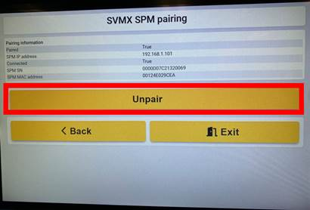

You should see a green check and a message showing that the SPM is successfully unpaired as well as a False for a paired status.

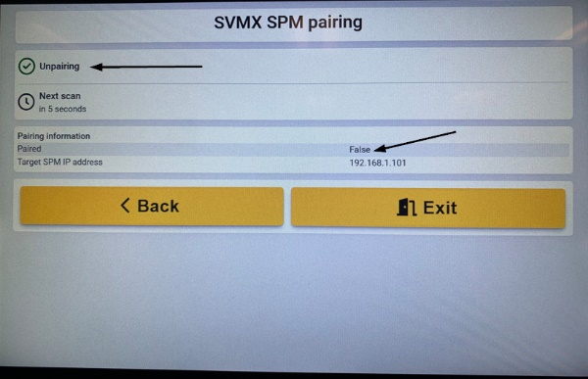

You can exit after it is unpaired.

Extract and place the Install folder and it’s contents onto the root of a blank USB Key formatted FAT32 only.
Place the Startup folder and it’s contents onto the root of another blank USB key formatted FAT32 only.

One key with the install folder should look like this,

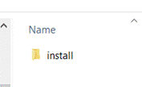

The other key with the Startup folder should look like this,

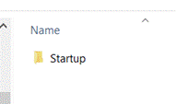

Insert the USB Key with the Install folder on it into the ANTX board and the install will start automatically and when finished it will reboot and come up. Remove the USB key once complete.

Insert the other USB key with the Startup folder into the SPM USB Port on the keypad itself and power cycle the unit. A receipt will start to print during the installation process of the SPM keypad, when finish the printing will stop and you can pull the paper to see if it was successful, if complete and successful remove the key and power cycle the unit. This process takes about 5-10 minutes, just keep an eye on it, it will print, stop for a while and then print again, so do not be fooled by the completion until it says success on the receipt, you should hear a cut of the paper when complete.

As the unit is booting up do the left right left screen taps to get into the programming when you see the One Moment Please screen,

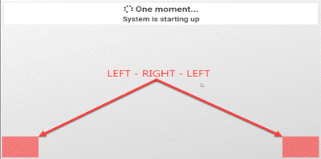

Once into programming you will select Configuration.

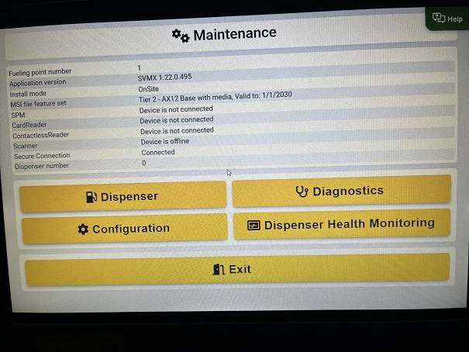

Access code is 8311 – Enter.

Select Edit Configuration,

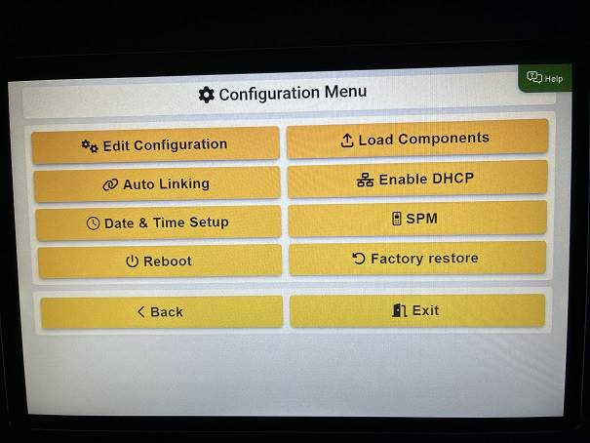

Select Application,

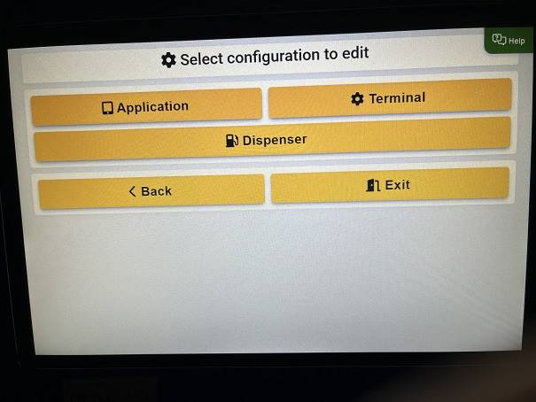

Select the drop down for the POS type and select the controller like Allied, and then the Variant select Passthru, even it is already has passthru selected.

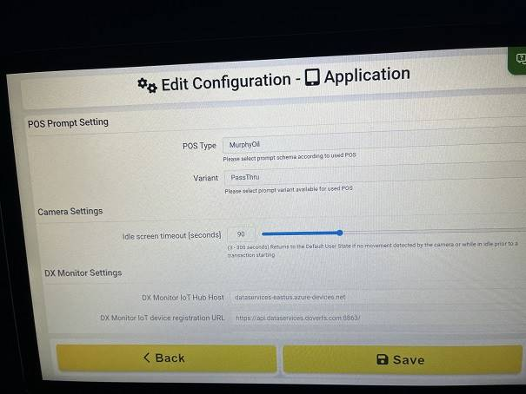

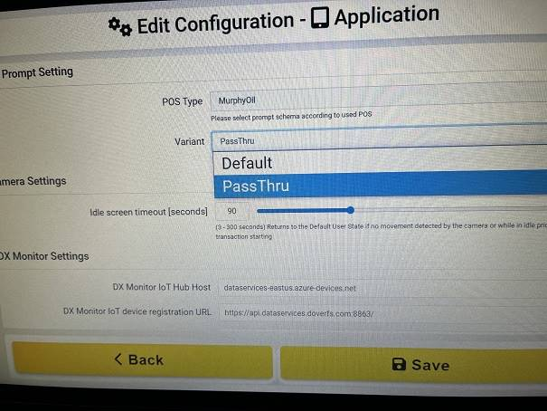

Scroll down and uncheck intercom and select Save.

Go back into Application, scroll down and check intercom again, select Variant Passthru, even it is already set to Passthru and selected Save, this is to ensure that the settings are saving even if they are already set in the UI.

Select back until you see an option for SPM.

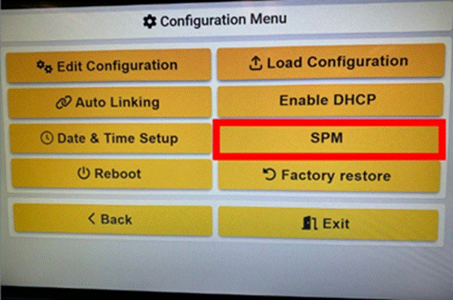

You are going to want to Pair the SPM, wait for the count down and when you see the Pair button appear, select Pair, it should pair successfully.

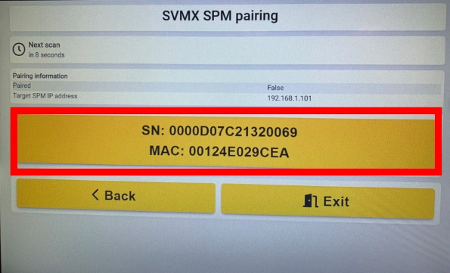

Select back a couple of times until you see Dispenser Health Monitor, select Dispenser Health Monitor,

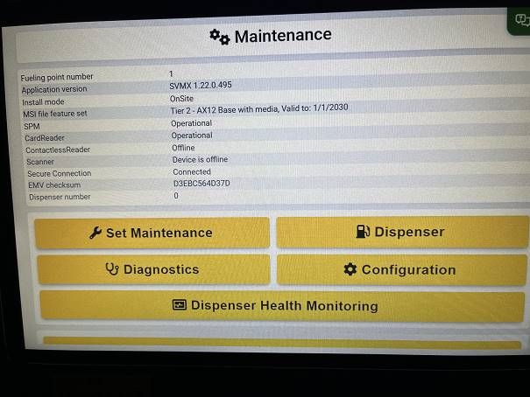

All of the items should go Red in a moment,

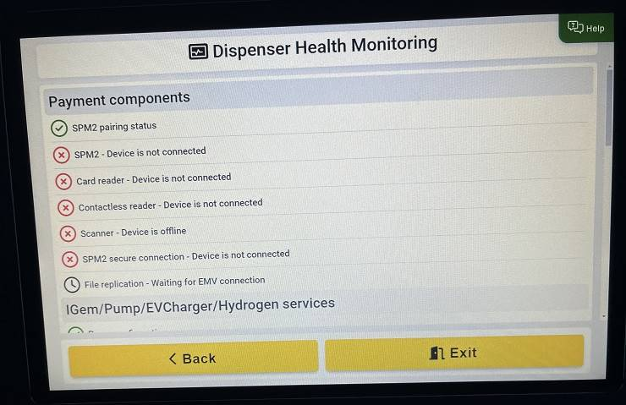

Wait until all of the ones shown above turn Green, this may take several minutes,

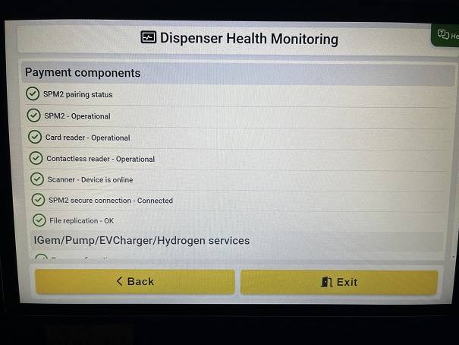

Select Exit and you should be seeing the Out of Service message,

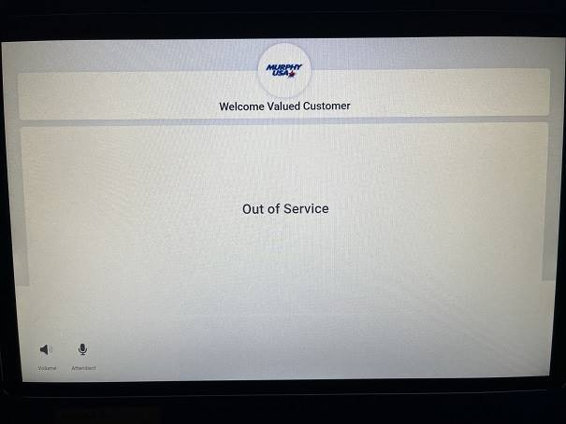

You can do the Left, Right, Left here on the screen to get into the configuration screen to review.

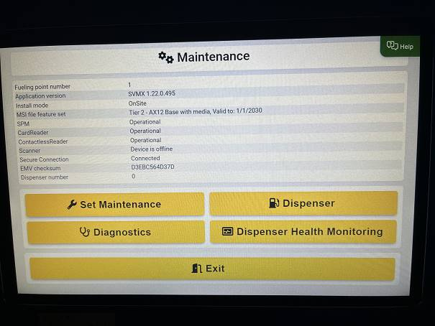

You can This will display the version of Anthem that is installed.

