

iXPay EMV Software Installation Instructions

EMV North America

Version 2.8 series

Date 06/18/2020

Purpose: Instructions on how to install iXPay (1) EMV Software onto Wayne Simulators. Every effort has been made to ensure the following information is correct at the time of this publication. It is assumed that these instructions will be followed in order, any deviation to this document and the steps in specific order may result in a system that may become unusable.

Required Material:
- USB key, preferable 4mb or smaller, formatted FAT. FAT32 and exFAT are not supported.
- Laptop or PC
- iXPay EMV software

- Board Type

Determine which board type you have installed in your simulator, iX Jade or iX Red. Both boards are the same footprint, same connectors, etc.

iX Jade Board iX Red Board
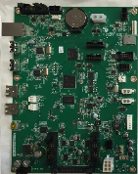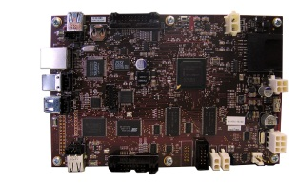

- Screen Type

Determine Screen type installed based on connector used and size.

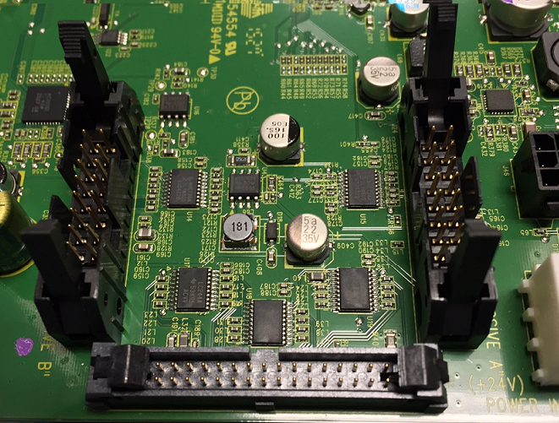

The video connectors on the side of the board are for both iX Red and iX Jade boards, connectors are the same for each board for screen size and type.

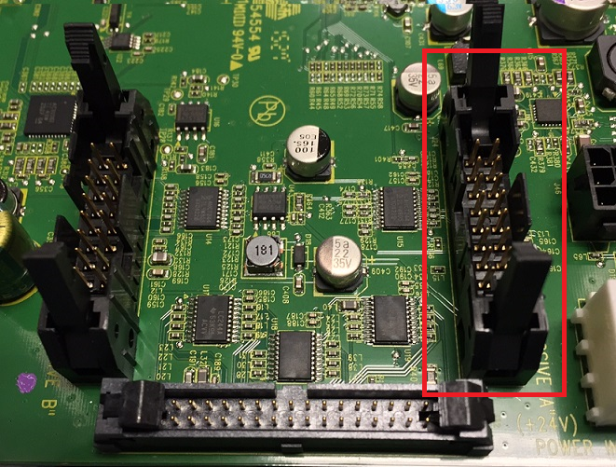

If you have a cable connected to the above connector marked in Red, this will be a 5” Mono qVGA screen.

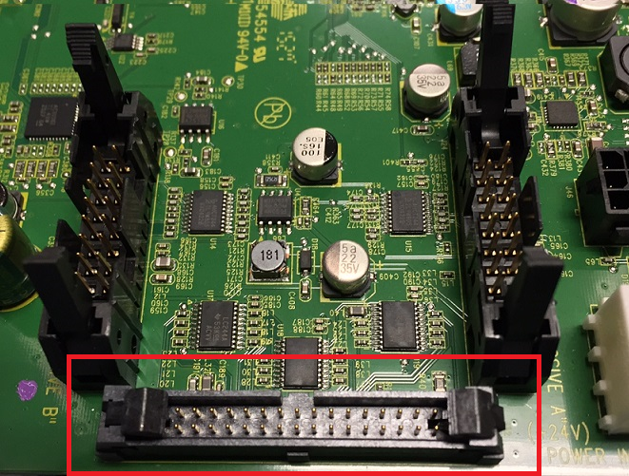

If you have a ribbon cable connected to the above connector marked in Red, this will be either a 10” Color VGA or a 5” Color qVGA screen. Measure the screen diagonally to determine 5” or 10”.

- Identifying Software Package

All simulators are considered Dual Board configurations since there is only 1 side/Fueling Point) per simulator (DualBoard meaning two boards per dispenser, not sides).

You can now determine what software package needs to be installed once Board and Screen types has been identified.

Examples:
Jade 5 inch Mono qVGA
Jade 5 inch Color qVGA
Jade 10 inch Color VGA
Red 5 inch Mono qVGA
Red 5 inch Color qVGA
Red 10 inch Color VGA

- Configuring USB Key

Each installation package consists of two parts, the installation software(Service Utility) and the iX Software(EMV). Under each package you will find the following,

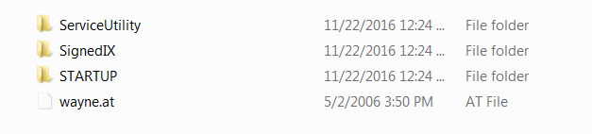
ServiceUtility, Startup, and wayne.at is part of the installation software and the SignediX folder is the iX Software itself that will be installed.

iX boards will only accept certain USB Keys since not all USB device drivers are loaded into the OS being installed, so some keys may work better (faster) then others and some not at all. With this in mind, iX Boards will only support USB Keys that are formatted FAT, this will not work formatted in FAT32 or exFAT, only 2gb FAT is supported, larger ones must be partitioned accordingly to support FAT.

Once the key is formatted with FAT, extract the contents of the appropriate iX Package onto the root of the USB Key, USB Key root should look the same as above with ServiceUtility, SignedIX, Startup, and Wayne.at.

To change the IP Address that will be assigned to the Terminal, the iXPayMain\SystemConfig.xml file is where the IP, DHCP, and DNS settings are stored. Warning: Take great care in modifying XML files, please do not change the format, tags, encoding, etc. and use the proper XML editing tools when making any changes. Changing formats, encoding, etc. to these files may result in a non-functional terminal.

IpAddress Prefix is the first three octets of the IP Address you wish to use, the offset will be the first IP Address used based on fueling point address. Fueling Point 1 will become 192.168.1.101, Fueling Point 2 will be .102, and so on. We do not use the offset2 or startFP2, those can remain the same as the default, adjust your Subnetmask and DNS if need be. To turn on DHCP, change the enable=”false” to “true”.

<SystemName prefix="ixPAY" />
<NetworkAdapter name="\Comm\DM90001\Parms\TcpIp" />
<DHCP name="EnableDHCP" enable="false" />
<DefaultGateway name="DefaultGateway" ip="192.168.1.1" />
<IpAddress name="IpAddress" prefix="192.168.1" offset="101" offset2="132" startFP2="32"/>
<Subnetmask name="Subnetmask" ip="255.255.255.0" />
<DNS name="DNS" ip="192.168.1.1" />

After the extraction and any modifications that have been made, Insert the USB Key into any one of the available USB Ports on the iX Board and simply power Off/On.

CAT will reboot and show the Ovation Splash Screen followed by the Installation software.

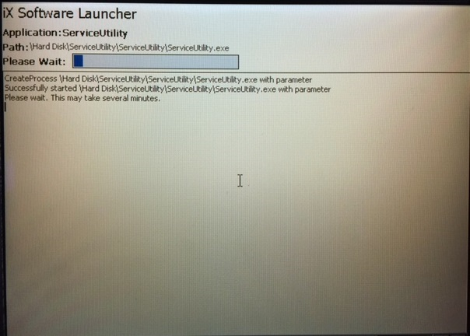

Using a 10” Color VGA screen examples for ease of viewing, the launcher will come up to the software menu, select SW Upgrade soft key followed by iX Software soft key on the next menu.

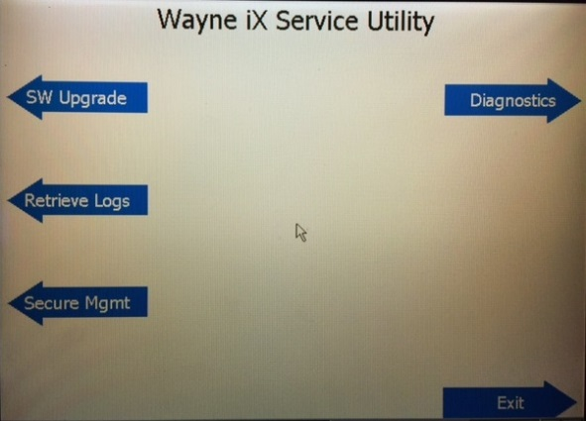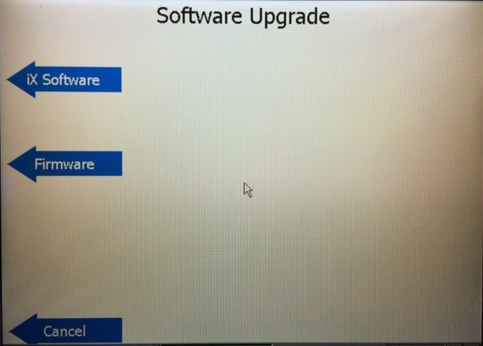

The version screen will appear, validate Current Version and Proposed Version and select the Upgrade soft key.

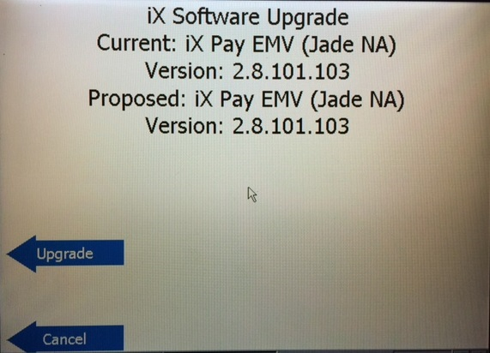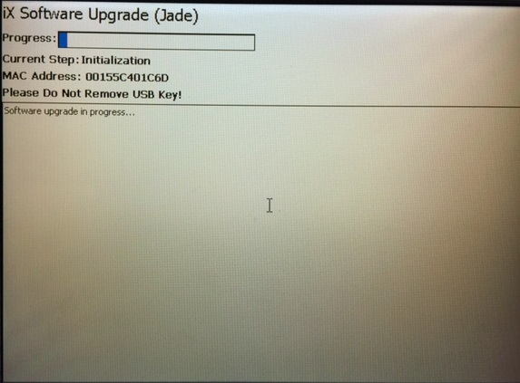

Software will begin the installation process. During this process, the CAT will reboot after installing the operating system, and will continue the installation process.

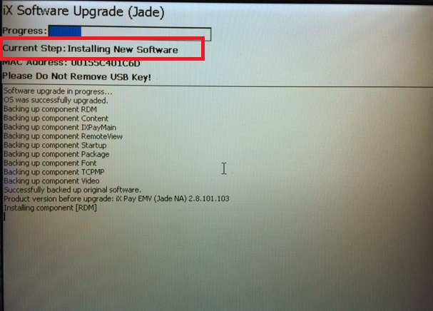

Do Not Remove the USB key until the installation is complete and the screen instructs you to do so (. Failure to let the installation process complete may result in a simulator that may become unusable.

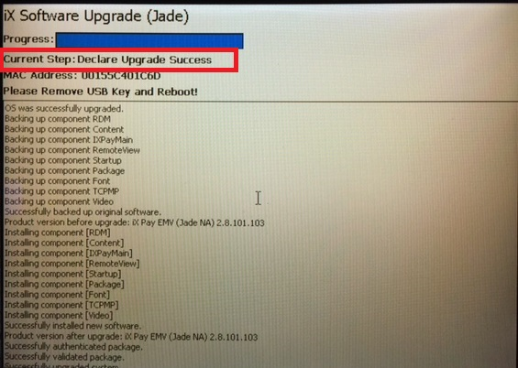

Once the installation is complete, remove the USB Key and power off/on.

Ovation iX splash screen will appear followed by the Windows CE Desktop followed by the first configuration screen.

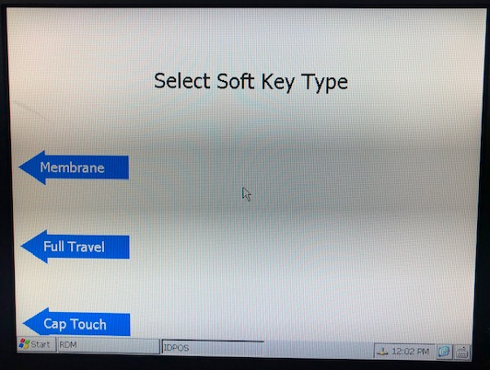

There are three types of soft key hardware, Membrane, Full Travel and Capacitive touch.

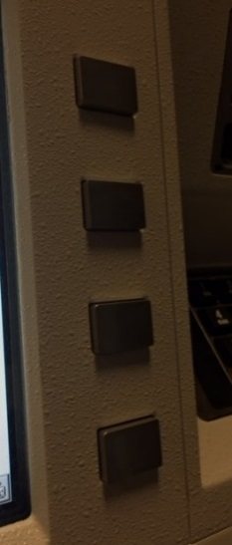 | 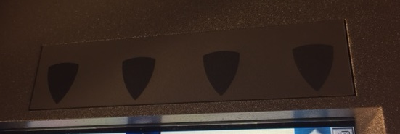 | 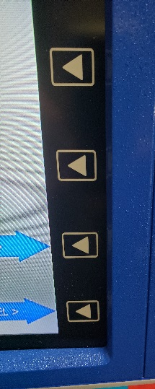
Full Travel Softkeys | Membrane Softkeys | Full Travel or  Capacitive

Full Travel softkeys are raised keys from the panel itself and can be depressed, shown on the left. Membrane softkeys are flat keys with a label that depresses, shown in middle. Capacitive touch is activated simply by touch.

Screen Orientation: If your screen is in the wrong orientation, upside down, backwards, etc., use the soft keys to change to the correct orientation. This is not common affect, but the screen is available in case the screen needs to be adjusted. Press Cancel is nothing needs to be changed.

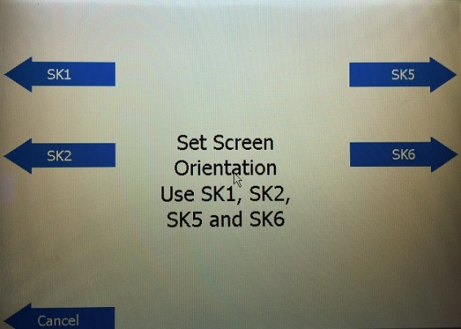

Terminal Number: This is the CAT Address you which to assign to the fueling point. Enter in the digit(s) on the keypad and press Enter on the keypad.

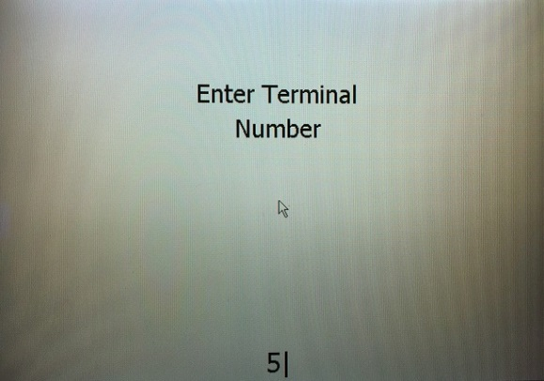

Side Selection: This is only used for remote monitoring, select Confirm for Side A. Rule of thumb, Even numbered fueling addresses are Side A and Odd numbered fueling addresses are Side B unless installed on the island differently to match signage, etc. Pressing Change soft key will change the side to B and when you have the selection you wish, press Confirm soft key.

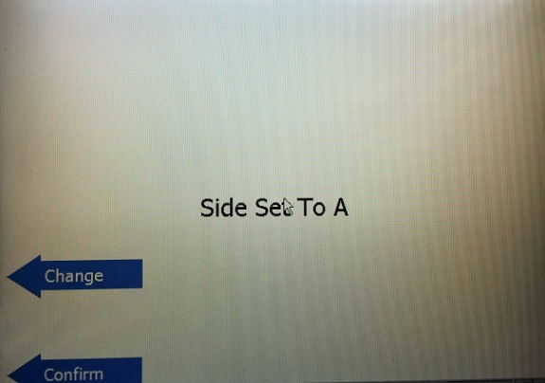

Date/Time Selection: Validate the Date and Time, Yes to Change and following the format that is listed to enter in the new date and time, or No to continue on. Cancel can also be selected if no changes are to be made on this screen.

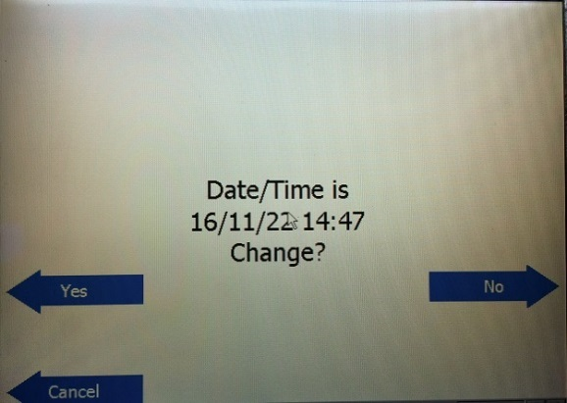

If remote monitoring is installed (iSense) select No to continue. Only select Yes for this option if the proper iSense equipment is installed and functional.

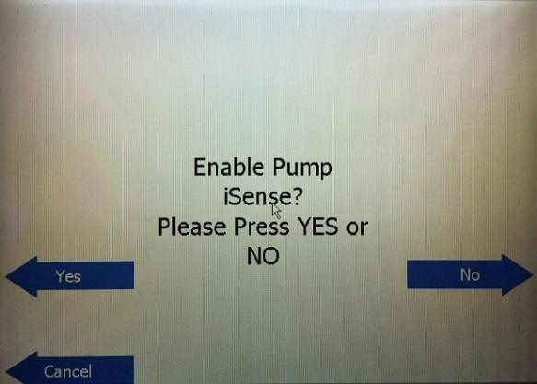

Scanner Type: There are two types of scanner, 1D and 2D readable scanners. The 1D scanner has a single line beam to read bar code whereas, 2D scanners have a cross beam. 1D shown on the left and 2D shown on the right below.

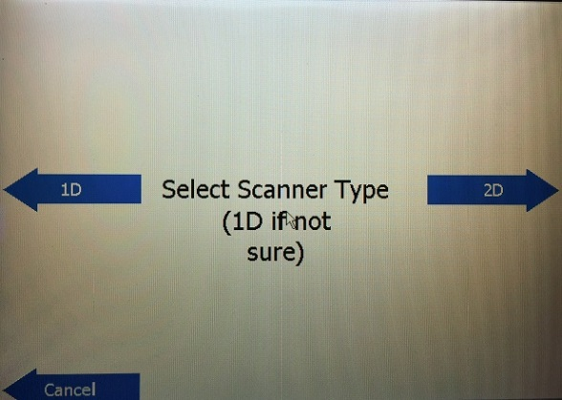



Select the appropriate bar code scanner installed, if no scanner is installed, select Cancel.

Printer Selection: There are multiple printers available, but will only show below what a Zebra looks like. The back of your simulator on the left side you will see the printer, the label on the top of the printer will say Zebra, if the printer installed is not the one shown below, select No for Zebra Printer. Additional Note: If printer is connected to SPM select “No” to Zebra. Look for the communication cable to see if you have USB cable going from the printer to the iX board, select USB for this configuration. If the communications cable goes the back of the keypad it is a Serial printer.

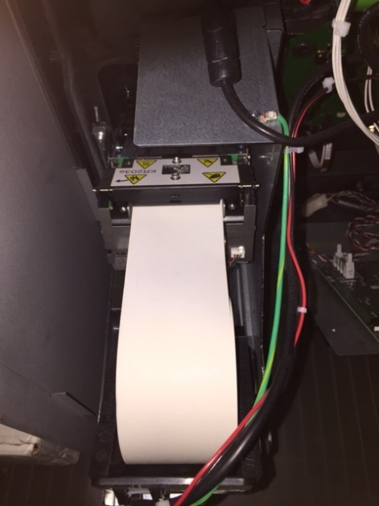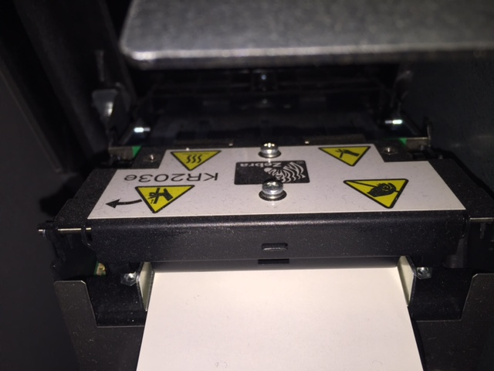

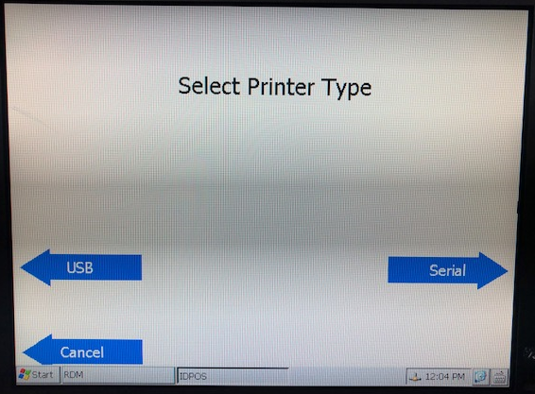

The next couple of prompts are diagnostics to make sure that the hardware itself is functioning properly. Press all of the soft keys on the right side and the left side, select Cancel to move to the next screen which is the keypad test. Press all of the keys on the keypad and function keys on the keypad to make sure that values appear at the bottom of the screen. Select Cancel to move to the next screen.

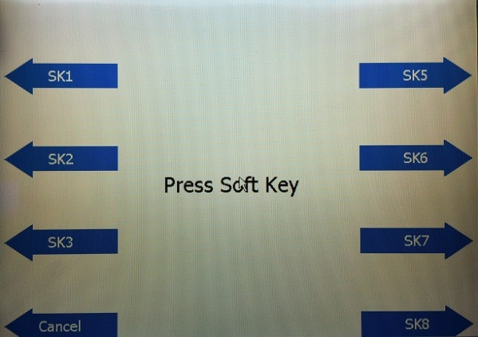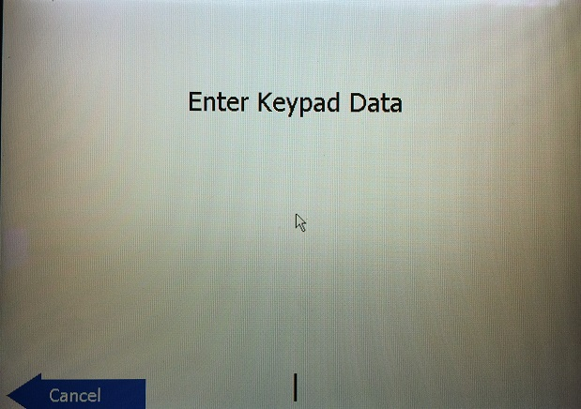

Media selection is not important unless you are going to be connected to IOTV or running iX Media offering. If neither of this offerings are being tested or used, select the Cancel soft key.

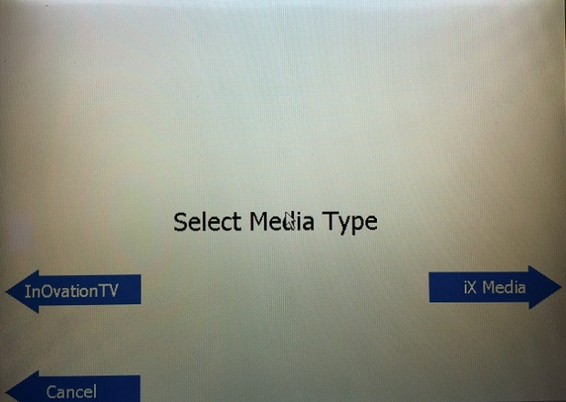

Pump test requires a special cable connected between iGEM and the iX Board. Not all simulators have this CANBUS cable, in almost all cases select the No or Cancel soft key to continue.

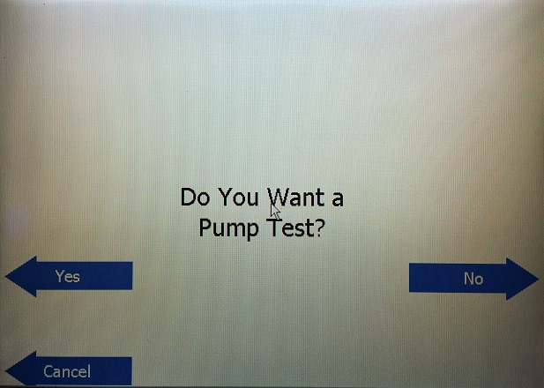

Next couple of screens are more diagnostics for Scanners, you can scan a bar code to test the device, select Cancel soft key to move to the Card Reader test, insert a card or chip card to test, select Cancel soft key to continue.

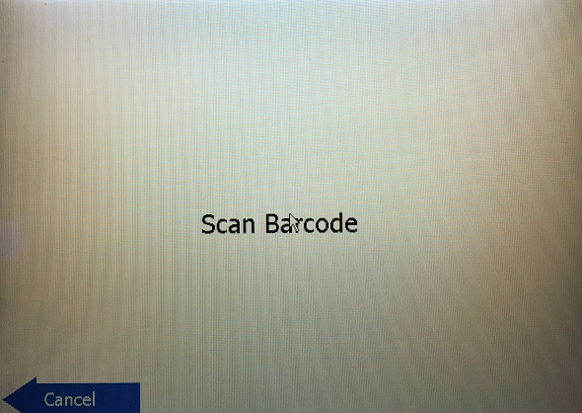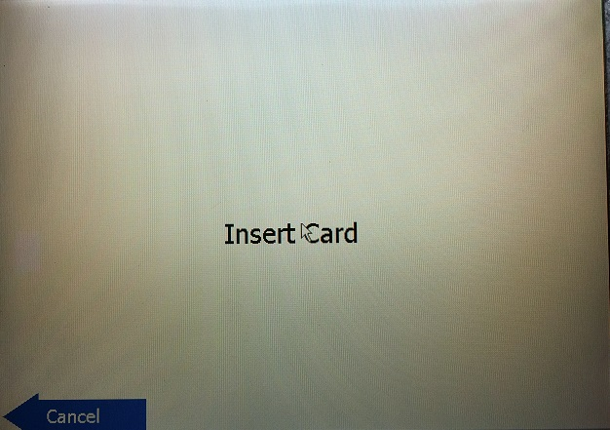

Once the configuration and diagnostics is complete, it will print out a configuration receipt, this is also testing the printer itself. If no print occurs, check paper, make sure that the right printer was selected, etc. Once the configuration receipt is printed, the reset screen will appear, select Reset soft key and the system will reboot to apply all changes.

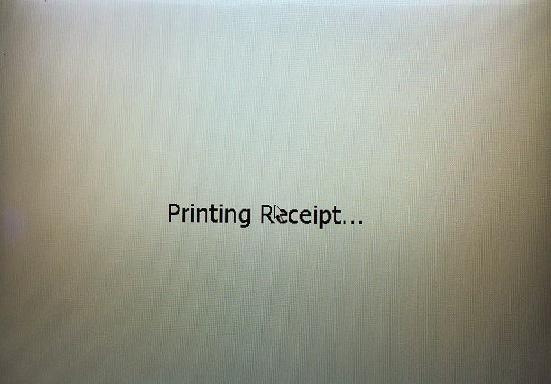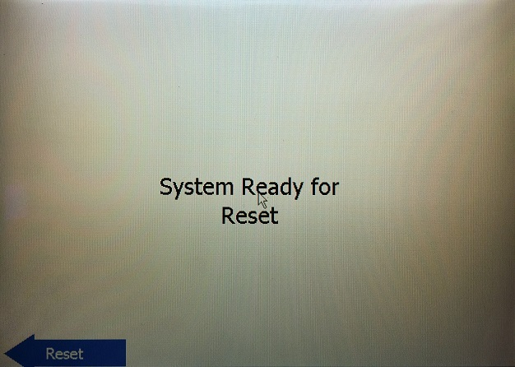

Once the system reboots to apply all of the configurations or changes, they system will either come up to a menu or will come up to the Please Pay Inside (E01) prompt which is the prompt where it is now available to start accepting communications from the controller.

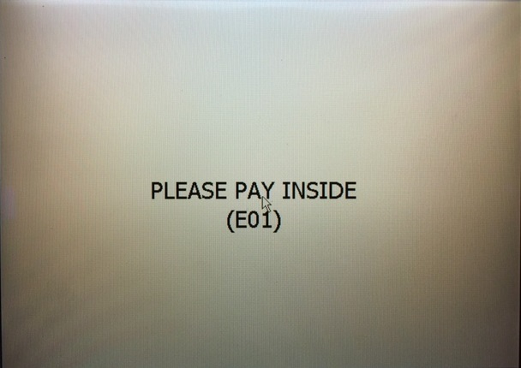

If it comes up to the menu shown below, the system is not in an operational state, full security has not yet been enabled. Select Operations soft key, to turn on all the security.

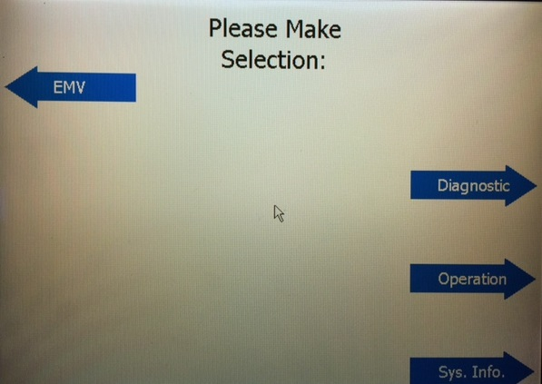

Enter in Access Code 8311 and press the Enter key on the keypad.

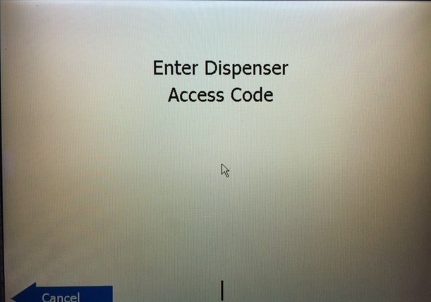

Press Ready soft key to confirm.

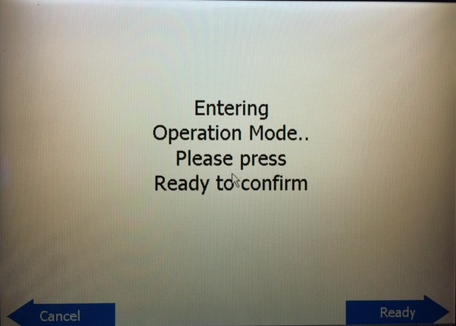

Operation Mode Selected screen will appear, press the Cancel soft key to exit back to the Menu screen, except now the option on the menu screen has changed to Maintenance. Press the Cancel soft key a couple of times and it will then exit to the Please Pay Inside (E01) prompt and ready to accept communications from the controller.

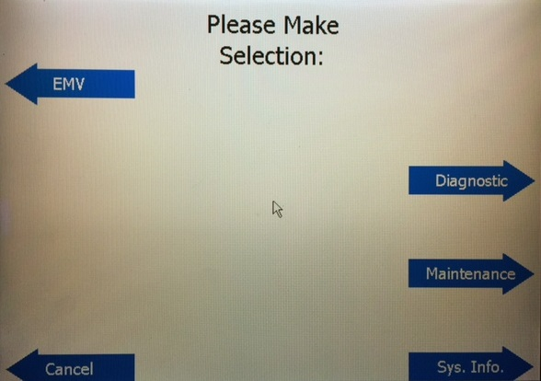

- Diagnostics

To enter into Run-Time Diagnostics to test any one of the devices that were tested during configuration, press the second soft key down from the top on both sides at the same time, do not need to hold them, just press them at the same time, this can be done at any time. The same menu screen will appear, select Diagnostics soft key. Enter in the Access Code of 8311 and press Enter on the keypad.

From this Diagnostics Menu, you can select any device to test. Contact Reader test is the same as a Card Reader test. Select Cancel soft key to exit back to the menu above, select Cancel from the menu to exit Run-Time Diagnostics taking you back to the Please Pay Inside (E01) prompt.

